NJSC "Karaganda Medical University"

ANNOTATION
Doctoral Dissertation Abstract
for the degree of Doctor of Philosophy (PhD)

«Treatment of Infected Wounds Using Alginate-Based Dressings with Antibacterial and Regenerative Properties»

Specialty: 8D10100 – Medicine
Author: Aliya Mukhtarovna Atepilieva

Scientific Supervisors:
PhD, Associate Professor, Deputy Director for Science and Education, National Scientific Center of Traumatology and Orthopedics named after Academician N.D. Batpenov, Astana, Republic of Kazakhstan— Dina Azimovna Saginova
PhD, Professor, Chief Researcher of the Stem Cell Laboratory of the National Center for Biotechnology, Astana, Republic of Kazakhstan — Vyacheslav Borisovich Ogai
Candidate of Medical Sciences, Associate Professor, Department of Traumatology and Orthopedics, Peoples' Friendship University of Russia (RUDN University), Russian Federation — Denis Vladimirovich Rimashevsky

Republic of Kazakhstan
Astana, 2025
Relevance
The problem of antibiotic resistance and delayed healing of infected wounds remains one of the key challenges in modern medicine. Despite the wide variety of wound dressings available on the market, many of them fail to provide both antibacterial activity and stimulation of tissue regeneration simultaneously. This issue is particularly important for patients with chronic diseases, in whom the healing process is significantly impaired.
Modified alginate-based dressings containing antibacterial components and growth factors represent a promising approach to address this problem. Such dressings are capable of combining antimicrobial activity with regenerative support, making them a highly prospective tool in the treatment of infected wounds.

Objective
To investigate the outcomes of a two-stage system of innovative alginate-based wound dressings with antibacterial and regenerative properties in a rat model of infected wounds.
Research Objectives
- To develop a two-stage wound dressing system based on an alginate matrix with antibacterial and regenerative properties.
- To establish an experimental rat model of infected wounds for evaluating the effectiveness of the innovative dressing.
- To assess planimetric parameters of wound healing dynamics in the experiment.
- To evaluate microbiological and histological parameters of wound healing dynamics in the experiment.

Scientific Novelty
For the first time, a domestically developed two-stage wound dressing system based on an alginate matrix with antibacterial and regenerative properties has been proposed for the treatment of infected wounds (Appendix A. Certificate of State Registration of Copyright No. 52191, December 4, 2024, “Experimental model of purulent wound in rats under immunosuppression induced by pristane”).
For the first time, the formation of an infected wound in laboratory animals was modeled using pristane at a dose of 0.5 mL administered intraperitoneally (Appendix B. Utility Model Patent No. 10586).
For the first time, microbiological, histological, and planimetric parameters of wound healing dynamics were investigated in a comparative experimental study using a two-stage innovative wound dressing system created on the basis of a modified alginate matrix with antibacterial and regenerative properties.

Theses Submitted for Defense
- The developed two-stage domestic wound dressing system based on an alginate matrix demonstrates antibacterial properties due to the combined action of the antibiotic cefepime and silver ions, and improves wound regeneration through the incorporation of growth factors (FGF-2).
- The proposed method of wound modeling in animals using pristane (0.5 mL intraperitoneally) allows the formation of an infected wound after a single administration.
- The developed wound dressings provide a statistically significant reduction in microbial contamination (up to complete eradication of pathogenic flora by day 7), contribute to a more pronounced reduction in wound area (by 50.5% compared to standard therapy), and accelerate reparative processes, which is confirmed by a fourfold increase in the re-epithelialization index.

Practical Significance
The conducted experimental study substantiates the feasibility of applying this wound dressing system in clinical practice as an alternative method for the treatment of infected wounds.
Such dressings provide not only antimicrobial activity and a reduced risk of complications, but also stimulation of regenerative processes, which leads to faster and higher-quality tissue repair. They also reduce the number of dressing changes, prevent adhesion and sticking to the wound, and protect against premature drying, thereby minimizing additional trauma.
The dissertation results provide a foundation for the development of new biomaterials with combined properties, which, after further clinical trials, may be introduced into practical healthcare.

Economic Significance
The economic effect of this research lies in the possibility of producing a domestic innovative wound dressing, thereby reducing dependence on imported materials and decreasing procurement costs. The development and implementation of this dressing in the Republic of Kazakhstan will ensure the availability of a modern and effective treatment method for a wide range of patients with infected wounds.

Social Significance
The stimulation of tissue regeneration reduces treatment duration, frequency of hospitalizations, and risk of complications. This helps decrease the level of disability among patients with infected wounds, improves their quality of life, increases social and professional activity, and reduces the burden on the healthcare system, including the costs of long-term treatment and rehabilitation. The implementation of such technologies has both economic and substantial social significance, contributing to overall improvements in public health.

Relation of the Dissertation to Other Research Projects
The dissertation was carried out within the framework of the grant funding of the Ministry of Science and Higher Education of the Republic of Kazakhstan, Project No. AP13608136 “Development of alginate wound dressings with enhanced antibacterial and regenerative properties for the treatment of purulent wounds.”
This study is part of the project and is aimed at the development and preclinical evaluation of the effectiveness of an innovative wound dressing, in line with the program’s objectives to improve methods for treating infected wounds. The results of this dissertation contribute to achieving the overall project goal and confirm the potential of modified alginate dressings in medical practice.

Author’s Contribution
The doctoral candidate, together with scientific supervisors and the research team, developed an innovative wound dressing with antibacterial and regenerative properties for the treatment of infected wounds. The researcher independently conducted experiments on 70 laboratory rats (modeling of infected wounds, collection of material for histological analysis, euthanasia, application of the wound dressing, dressings, and observations) to study structural changes in the wound area and evaluate the effectiveness of the developed system of wound dressings.
The doctoral candidate independently performed the collection, processing, and analysis of the obtained experimental data, as well as the generalization and description of the results, and wrote all chapters of the dissertation.
The work included the development of an experimental model of infected wounds and evaluation of the healing process using morphological, microbiological, and planimetric studies. The results were thoroughly systematized, analyzed, and presented in the dissertation by the author personally.

Approbation of the Work
The main provisions of the dissertation were presented and discussed at the poster competition “PhD Day” (Astana, April 2023), at the International Scientific and Practical Conference “Horizons of Modern Traumatology and Orthopedics” (Astana, Kazakhstan, August 2023), at the European Congress of Orthopaedics and Traumatology EFORT (Hamburg, Germany, 2024), at the Young Scientists’ Competition “Batpenov Readings” held within the framework of the IV Congress of Traumatologists and Orthopedists of the Republic of Kazakhstan with international participation (Astana, Kazakhstan, August 2024), at the European Congress of Orthopaedics and Traumatology EFORT (Lyon, France, 2025), and at the extended meeting No. 7 of the Department of Surgical Diseases of Karaganda Medical University (Karaganda, February 26, 2025).

Publications
Based on the dissertation materials, 5 scientific papers have been published, including one publication in an international scientific journal indexed in the Scopus database at the 74th percentile at the time of publication, and 4 publications in scientific journals recommended by the Committee for Quality Assurance in the Sphere of Education and Science of the Ministry of Science and Higher Education of the Republic of Kazakhstan.

Materials and Methods
Stage 1. Development, modification, and evaluation of wound dressings.
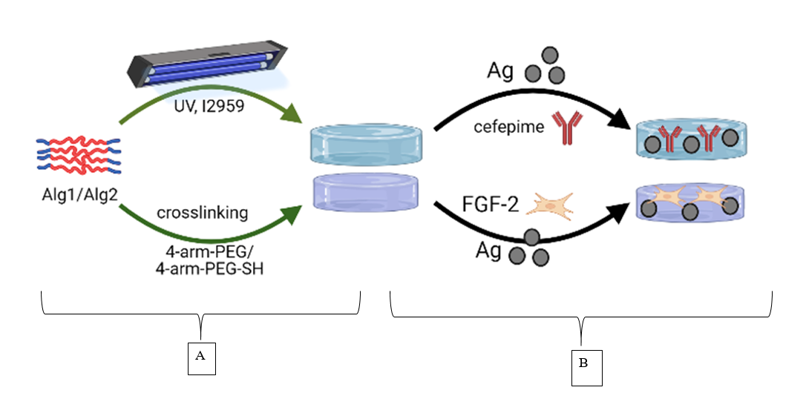
Stage 2. Modeling of infected wounds in rats
Modeling of Infected Wounds in Rats (n = 30)

Hydrocortisone (n = 10)

- No Immunosuppression (n = 10)

Pristane (n = 10)

Induction of Pathology
- Surgical intervention
- Wound contamination

Days 3 and 7 – Microbiological and planimetric evaluation

Stage 3. Evaluation of the effectiveness of the two-stage alginate-based wound dressing system with regenerative and antimicrobial properties
Evaluation of treatment efficacy in rats (n=50) after preliminary immunosuppression

On day 7 – induction of pathology and contamination

On day 10 – evaluation of infection in the wound, start of treatment

Treatment


Daily dressings with Levomekol ointment
Day 1 – repeated contamination, application of stage I dressing

Day 3 – replacement of dressing with stage II

Day 7 – termination of treatment, removal of fixation rings

Withdrawal of animals from the experiment

Histological examination

Results and Conclusion
In this study, an innovative two-stage wound dressing system based on a modified alginate matrix was developed, providing controlled release of active components. The first layer contained the antibiotic cefepime and silver ions, ensuring strong antimicrobial activity, while the second layer incorporated silver ions and fibroblast growth factor (FGF-2), stimulating tissue regeneration. Modification of the alginate matrix by crosslinking with pentenyl anhydride enabled slow swelling and gradual hydrolysis, which prolonged component release and enhanced therapeutic effectiveness.
To create a model of infected wounds in rats, immunosuppression was induced using hydrocortisone and pristane. Hydrocortisone required frequent administration and resulted in a less pronounced infection. In contrast, pristane induced persistent local inflammation, high bacterial load, and delayed healing. The control group without immunosuppression rapidly overcame infection, making it impossible to reproduce chronic infected wounds without immune suppression. Thus, the pristane-based model was recognized as optimal for therapeutic evaluation.
The effectiveness of the wound dressings was evaluated in 50 rats divided into 5 groups. The group treated with SA+Cpm+Ag+FGF-2 demonstrated the greatest reduction in bacterial load (by 55.6% on day 3, with complete eradication by day 7) and significantly accelerated wound healing (nearly twofold reduction of wound area by day 14). Histological analysis confirmed accelerated re-epithelialization and formation of a mature collagen structure. Dressings containing individual components and standard treatment were less effective.

Based on the experimental findings, the following conclusions were drawn:
- The developed two-stage wound dressing system based on a modified alginate matrix exhibits antibacterial activity due to the combined effect of the antibiotic cefepime and silver ions, and accelerates wound healing through the incorporation of the growth factor FGF-2.
- The experimental rat model of infected wounds using pristane reliably delayed wound healing (reduction in wound perimeter by 0.32 mm and area by 0.48 mm in both groups). The reproducibility of this model for assessing antibacterial and regenerative therapies was confirmed by a higher bacterial load in the pristane group, which exceeded the hydrocortisone group by 1.1-fold (p = 0.01).
- Comparative evaluation of treatment with the two-stage alginate-based system containing silver ions, cefepime, and FGF-2 demonstrated a 2.2-fold greater reduction in wound area compared to the Control group treated with Levomekol ointment. Wound perimeter decreased by 31% more than in the Control group (p = 0.01).
- Application of the two-stage system based on modified alginate containing silver ions, cefepime, and FGF-2 resulted in a complete absence of bacteria by day 14 (<10 CFU/ml, p = 0.0001). The combined dressing (silver particles + cefepime) showed statistically significantly higher efficacy in stimulating reparative processes in the infected wound model in rats compared to Levomekol ointment in the Control group (p = 0.01). According to histological assessment using the HEALS-A scale, 60% of animals in the SA+Cpm+Ag+FGF-2 group achieved pronounced (R3) or complete (R4) morphological regeneration, whereas in the Control group no cases of pronounced regeneration (R3–R4) were observed, and 90% of animals demonstrated incomplete or early proliferation stages (R0–R1). According to the SPOT scale, regeneration was accompanied by the formation of a continuous epithelium (re-epithelialization index 4 times higher than in the Control group), mature granulation tissue with moderate scarring (index equal to 0 in the Control group), and partial restoration of skin appendages (remodeling index 30% higher in the experimental group).

References

- Ogay V, Mun EA, Kudaibergen G, et al. Progress and prospects of polymer-based drug delivery systems for bone tissue regeneration. Polymers. 2020; 12(12): 2881.
- Shi Q, Luo X, Huang Z, et al. Cobalt-mediated multi-functional dressings promote bacteria-infected wound healing. Acta Biomater. 2018; 86: 465-479.
- Chen K, Wang F, Liu S, et al. In situ reduction of silver nanoparticles by sodium alginate to obtain silver-loaded composite wound dressing with enhanced mechanical and antimicrobial properties. Int J Biol Macromol. 2020; 148: 501-509.
- Singh M, Thakur V, Kumar V, Raj M, Gupta S, Devi N, Upadhyay SK, Macho M, Banerjee A, Ewe D, Saurav K. Silver Nanoparticles and Its Mechanistic Insight for Chronic Wound Healing: Review on Recent Progress. Molecules. 2022 Aug 30;27(17):5587. doi: 10.3390/molecules27175587. PMID: 36080353; PMCID: PMC9457915.
- Lin X, Guan X, Wu Y, et al. An alginate/poly(N-isopropylacrylamide)-based composite hydrogel dressing with stepwise delivery of drug and growth factor for wound repair. Mater Sci Eng C. 2020; 115: 111123.
- Hossein AR, Farhadian N, Karimi M, et al. Ceftriaxone sodium loaded onto polymer-lipid hybrid nanoparticles enhances antibacterial effect on gram-negative and gram-positive bacteria: Effects of lipid-polymer ratio on particle size, characteristics, in vitro drug release and antibacterial drug efficacy. J Drug Deliv Sci Technol. 2021; 63: 102457.
- Kim S-W, Im G-B, Jeong G-J, et al. Delivery of a spheroids-incorporated human dermal fibroblast sheet increases angiogenesis and M2 polarization for wound healing. Biomaterials. 2021; 275: 120954.
- Zhang M, Zhao X. Alginate hydrogel dressings for advanced wound management. Int J Biol Macromol. 2020; 162: 1414-1428.
- Blessing AA, Buyana B. Alginate in wound dressings. Pharmaceutics. 2018; 10(2): 42.
- Dolati S, Yousefi M, Pishgahi A, et al. Prospects for the application of growth factors in wound healing. Growth Factors. 2020; 38(1): 25-34.
- Dinh T, Braunagel S, Rosenblum BI. Growth factors in wound healing: The present and the future. Clin Podiatr Med Surg. 2015; 32(1): 109-119.
- Han SK. Innovations and Advances in Wound Healing. Springer; 2015. 206 p.
- Riabov V., Salazar F., Htwe S.S., Gudima A., et al. Generation of anti-inflammatory macrophages for implants and regenerative medicine using self-standing release systems with a phenotype-fixing cytokine cocktail formulation. Acta Biomaterialia. 2017; Vol. 53: 389–398.
- Sheng J., Xu Z. Three decades of research on angiogenin: a review and perspective. Acta Biochim Biophys Sin (Shanghai). 2016; Vol. 48(5): 399–410.
- Tuganbekov T, Ashimov N, Saipiyeva D. Experience in the application of interval vacuum therapy with Vacumed device in complex treatment of lower extremity trophic ulcers. Journal of Clinical Medicine of Kazakhstan. 2014;2(32):60-4.
- Parry D.A., Craig A.S. Collagen fibrils and their role in the mechanical properties of connective tissues. Connective Tissue Research. 1984; 14(2): 91–104. doi:10.3109/03008208409008946.

